Day 38 – NOT Gate Using MUX

Introduction: A NOT gate produces the complement of the input.

Design: A 2:1 MUX is used to implement the NOT gate.
- I0 = 1
- I1 = 0
- Select = A
- Output = Y
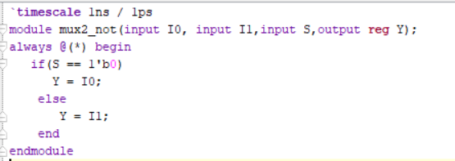

Testbench:
The testbench checks both input conditions.
A = 0 → Y = 1
A = 1 → Y = 0

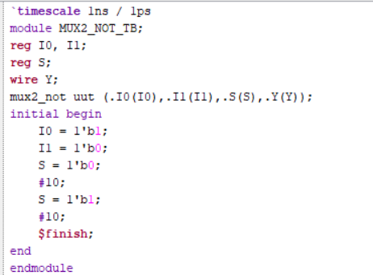

Schematic:

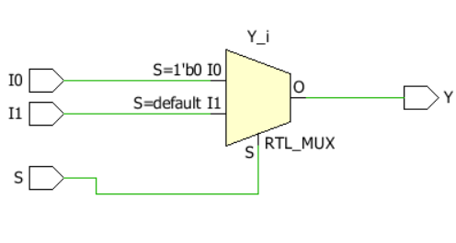

Waveform:
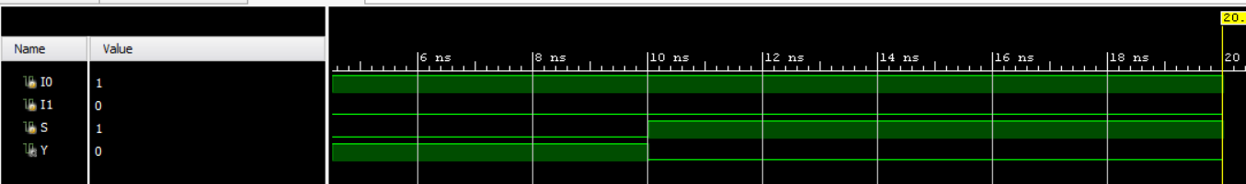

Design
A 4:1 MUX is used to implement the NOT gate.
- Input: A
- Select lines: connected according to the design
- MUX inputs are assigned to produce ~A
- Output = Y
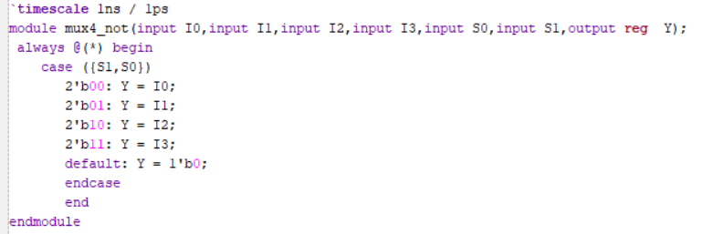

Testbench:

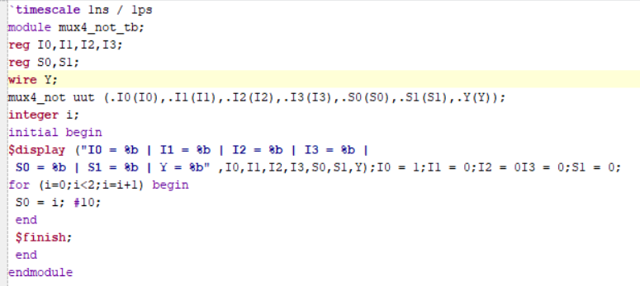

Schematic:

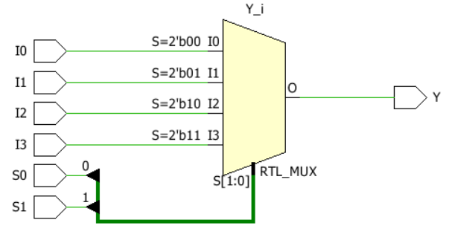

Waveform:

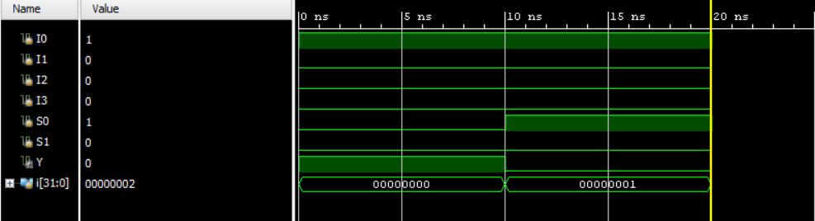
.

Observation
The NOT gate was successfully implemented using both 2:1 MUX and 4:1 MUX. In both designs, the output correctly produces the complement of the input.
A = 0 → Y = 1
A = 1 → Y = 0

#PHANEENDRA.SINGUDASU

